**ACTUATORS**

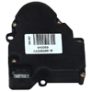 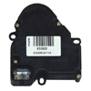 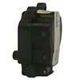 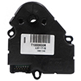

**NEKY2113005 NEKY2113007 NEKY2113009 NEKY2113010**

INTERNATIONAL 3542575C2 FREIGHTLINER BSM650625 FREIGHTLINER BOA91594 FREIGHTLINER 301459

INTERNATIONAL 3524465C1 INTERNATIONAL ZGG717056 FREIGHT/OEM VCC32000022

INTERNATIONAL ZGG717057

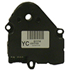 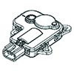 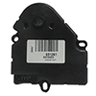 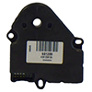

**NEKY2113015 NEKY2113016 NEKY2115003 NEKY2117005**

INTERNATIONAL 3599602C1 INTERNATIONAL 2503207C1 FREIGHT/ALLIANCE 3280020

FREIGHT/OEM BSM 3280020

INTERNATIONAL ZGG717002

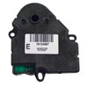 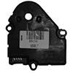 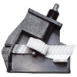 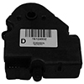

**NEKY2117006 NEKY2118004 NEKY2199012 NEKY2199066**

International ZGG717063 BLUEBIRD 00090191 INTERNATIONAL 1664769C92 FREIGHT/ALLIANCE 301269

INTERNATIONAL 3685800C1 INTERNATIONAL ZGG717061

**PHONE 1-866-934-7665 FOR PRICE AND AVAILABILITY**

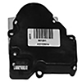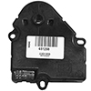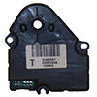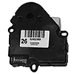

**NEKY2199067 NEKY2199069 NEKY2199073 NEKY2417002**

FREIGHTLINER/OEM BSM651291 BLUEBIRD 00063495 BLUEBIRD 00015310 INTERNATIONAL ZGG717065

INTERNATIONAL 1696831C1

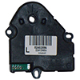

**NEKY2417003**

INTERNATIONAL ZGG717066

**PHONE 1-866-934-7665 FOR PRICE AND AVAILABILITY**