**CONTROL KITS**

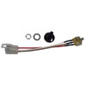 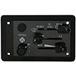

**KNOB & SWITCH KIT CONTROL PACKAGE**

**NEKY3899005 NEKY3899009**

**BLUEBIRD 00031148 INT 2209577C91**

**INT ZGG726017**