**CONTROL PANEL**

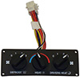 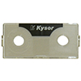 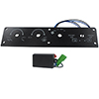

**NEKY3899007 NEKY3899012 NEKY3899014**

**FRT OEM BSM880014 INT ZGG733497 BLUEBIRD 00037786**

**THOMAS BUILT BUS 6600-4667**